

**The 14th PREŠOV OPEN 2016**

**INTERNATIONAL TOURNAMENT**

**TAEKWON-DO ITF**



**12. – 13. March 2015**

**ZŠ Sibírska, Prešov**

**www.gebaek.sk**



***General informations:***

**1. The head of organizing committee:**

Tomáš Olejár, e-mail: gebaek.presov@gmail.com

***ENTRY FORMS***

* The forms/competitor entry forms and accomodation forms/ please send to :



FAX: +421 51 77 44 773

E-mail: gebaek.presov@gmail.com

(We accept only entry forms fill in PC)

**2. Registration:**

**REGISTRATION DEADLINE:**

**Pre-registration - 3th march 2016 (until midnight)**

**Modifications - 10th march 2016 (until midnight)**

**ATTENTION!!! Pre-registration must be completed by all clubs until the first deadline. We can only accept an modifications (injuries, illnes, ...)from these clubs only.**

**3. Date and place:**

March 12th to 13th 2016, Prešov- Slovakia

**4. Address:**

Sport Hall ZŠ Sibírska, Prešov

Sibírska 42

Prešov

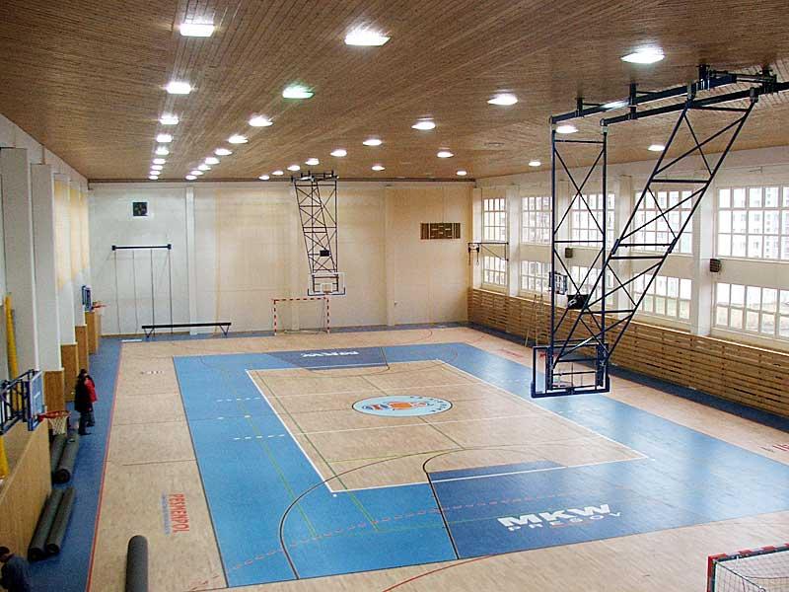

**Predbežný program súťaže:**

Saturday 12.03.2016

7:30 - 8:30 registration, weight in

8:30 - 9:00 referree meeting

9:15 beggining of the competition

Around 7pm finishing first competition day, medal awards

Sunday 13.03.2016

8:30 beggining of second competition day

Around 5pm finishing competition (depends on the number of competitors),

medal awards

**5. Division/ Categories:**

• Divisions/categories must consist of two or more competitors – if there is only one competitor he/

she will compete in a lower or higher category or division,

• Black belts m/f, coloured belts m/f,

• Children 6 – 10 years old, children 10 – 14 years old, juniors (15-17), seniors (18+),

• The event takes place in a round-robin system supported by a seeded draw, in case that in one

cathegory is more than 5 competitors, cathegory will be divided into groups and winners of the group

will continue in semifinals,

• The competitors have to have doctor control not older then 1 year.



***INDIVIDUAL EVENTS***

**PATTERN DIVISIONS CHILDREN 6-10 YEARS OLD M/F:**

• the competition is for competitors who have 10.kup and higher,

• pattern finals – one designated and one optional pattern,

• categories: : 10-8 kup, 7-6 kup, 5-4 kup, 3-1 kup, 1 dan, 2 dan and so on.

**PATTERN DIVISIONS CHILDREN 10 – 14 YEARS OLD M/F:**

• the competition is for competitors who have 10.kup and higher,

• pattern finals – one designated and one optional pattern,

• categories: : 10-8 kup, 7-6 kup, 5-4 kup, 3-1 kup, 1 dan, 2 dan and so on.

**PATTERN DIVISIONS JUNIORS/SENIORS M/F:**

• the competition is for competitors who have 10.kup and higher,

• pattern finals – one designated and one optional pattern,

• categories: 10-8 kup, 7-6 kup, 5-4 kup, 3-1 kup, 1 dan, 2 dan and so on.

**SPARRING DIVISIONS CHILDREN 6 – 10 YEARS OLD M/F:**

* from 10. kup and higher,

• children – male: -23kg, -27kg, -31kg, -35kg, -40kg, -45kg, +45kg

• children – female: -23kg, -27kg, -31kg, -35kg, -40kg, -45kg, +45kg

• one round 1x1,5minutes STOP SYSTEM

• finals 1x1,5 minutes STOP SYSTEM

• all children have to wear head guard protectors during the sparring.

**SPARRING DIVISIONS CHILDREN 10 - 14 YEARS OLD WEIGHT CATEGORIES M/F:**

* from 10. kup and higher,

• children – male: -30kg, -35kg, -40kg, -45kg, -50kg, -55kg, +55kg

• children – female: -30kg, -35kg, -40kg, -45kg, -50kg, -55kg, +55kg,

• two rounds 2x1,5minutes

• finals 2 x1,5 minutes

• all children have to wear head guard protectors during the sparring.

**SPARRING DIVISIONS JUNIORS /SENIORS– WEIGHT CATEGORIES M/F:**

* from 6. kup and higher,

• juniors male: -50kg, -56kg, -62kg, -68kg, -75kg, over 75kg,

• juniors female: -45kg, -50kg, -55kg, -60 kg, -60kg, -65kg, over 65kg,

• seniors male: -57kg, -63kg, -70kg, -78kg, -85kg, over 85kg,

• seniors female: -50kg, -56kg, -62kg, -68kg, -75kg, over 75kg,

• two rounds 2x2 minutes

• finals 2x2 minutes

• all juniors and seniors have to wear head guard protectors during the sparring.



**SPECIAL TECHNICS CHILDREN 6-10 M/F:**

* from 10. kup and higher,

|  |  |  |
| --- | --- | --- |
| **Technics** | **Children male** | **Children female** |
| Twimyo nopi apchagi | **130 cm** | **130 cm** |
| Twimyo jopcha jirugi | **60 cm** | **60 cm** |

**SPECIAL TECHNICS CHILDREN 10-14 M/F:**

* from 10. kup and higher,

|  |  |  |
| --- | --- | --- |
| **Technics** | **Children male** | **Children female** |
| Twimyo nopi apchagi | **160 cm** | **160 cm** |
| Twimyo jopcha jirugi | **80 cm** | **80 cm** |

**SPECIAL TECHNICS DIVISIONS JUNIORS/SENIORS M/F:**

* from 10. kup and higher,

|  |  |  |  |  |
| --- | --- | --- | --- | --- |
| **Technics** | **Juniors male** | **Juniors female** | **Seniors male** | **Seniors female** |
| Twimyo nopi apchagi | 230 cm | 190 cm | 260 cm | 220 cm |
| Twimyo dollyo chagi | 210 cm | 180 cm | 240 cm | 200 cm |
| Twimyo jopcha jirugi | 120 cm | 110 cm | 140 cm | 120 cm |
| Twimyo bandae dollyo chagi | 210 cm | **-** | 220 cm | **-** |
| Twimyo dolmyo yopcha jirugi | 210 cm | **-** | 220 cm | **-** |



**POWER BREAKING DIVISIONS JUNIORS/SENIORS M/F:**

* from 4. kup and higher,

|  |  |  |  |  |  |
| --- | --- | --- | --- | --- | --- |
| Technics | Sonkal yop taerigi | Yopcha jirugi | Dollyo chagi | Ap yoomuk jirugi | Bandae dollyo chagi |
| Junior M | 2 boards | 3 boards | 2 boards | 1 board | 1 board |
| Junior F | 1 | 2 | 1 | - - - | - - - |
| Senior M | 2 | 3 | 2 | 2 | 2 |
| Senior F | 1 | 2 | 2 | - - - | - - - |



***TEAM events***

**DIVISIONS OF THE CHILDREN 6 – 14 YEARS OLD TEAM PATTERN M/F:**

• team must consists of 5 persons,

• the possibility to combine several practitioners of clubs into one team,

• the possibility to combine boys and girls in to the one team,

**DIVISIONS OF THE JUNIORS/SENIORS TEAM PATTERN M/F:**

• team must consists 5 persons,

• the possibility to combine several practitioners of clubs into one team,

• the possibility to combine members of the higher and lower age category ( for example: junior team

can consists of 4 juniors + 1 child, senior team can consists of 4 seniors + 1 junior.

**DIVISIONS OF THE JUNIORS/SENIORS TEAM SPARRING M/F:**

• team consists minimum of 3 persons and maximum of 5 persons,

• the possibility to combine several practitioners of clubs into one team,

• the possibility to combine members of the higher and lower age category ( for example: junior team

can consists of 4 juniors + 1 child, senior team can consists of 2 seniors + 1 junior.

**- The organiser can change divisions according to participation.**

**6. Awardings:**

* Patterns, sparring divisions: 1, 2 a 2x3 places, medal and diploma,
* Special technics, power breaking: 1, 2, 3 place, medal and diploma,
* Top three clubs will be awarded cups.

**7. Entrance FEEs:**

* **20 eur (for all disciplines)**
* **Team 10eur (for all team disciplines tul+sparing)**
* The entry fees should be paid only in Euro and cash at registration. Credit cards or other payments than cash will not be accepted.

**8. Insurance**:

• all competitors must have full insurance coverage for eventualities.

**9. ACCOMMODATION :**

**Accommodation has to be arranged by the articipating clubs.**

**Recommended accommodation:**

* **Hotel Lineas : http://www.lineas.sk/**

**Budovateľská č.14**

**Prešov 080 01**

* **Hotel Polo : http://www.hotel-polo.sk/**

**Karpatská č. 18**

**Prešov 080 01**

* **Penzión Adam : http://www.pensionadam.sk/**

**Jarkova č. 16**

**Prešov 08001**

* **Penzión IN : http://www.pension-in.sk/**

**Slovenská č. 90**

**Prešov 080 01**

* **Domov Mládeže A. Duchnviča : http://www.dm-ad-po.sk/**

**Sabinovská č. 2**

**Prešov 080 01**

**We can also help you to find the best accommodation and book it for you! - Then fill up the**

**reservation form for accommodation and send it to gebaek.presov@gmail.com till 3th of**

**March !!!**

**10. Coaches:**

• Coaches must wear a training suit and gymnastic shoes and must accept and result given by the

umpires as protest will not be accepted

• The coaches meeting will take place on Saturday the 12th of March at 8.30 a. m. in Sport hall.

**11. Umpires :**

• Umpires have to wear the official dress.

• We would like to ask you to secure min. one umpire per club:

*1– 10 competitors* – club has to secure min. one umpire**; if not, the penalty is 20 Euro.**

*Over 10 competitors* – club has to secure min. two umpires**, if not, the penalty is 50 Euro.**

• Umpires can also compete only after agreement with organizing committee !!!

• The Organizing committee will **pay for umpires a meal and an accommodation !!!**

• The umpire meeting will take place on Saturday the 12th of March in Sport hall.

**12.REGISTRATION AND WEIGHT IN:**

* The Registration and Weight in will take place the 12th of March between 7:30 a.m. and 8:15 a.m. in The Sport hall. The clubs can register and weight in also on 11th of March in evening in Sport Hall (need to arrange with organizing committee)
* All competitors have to show during the registration their passport or another identification

document.