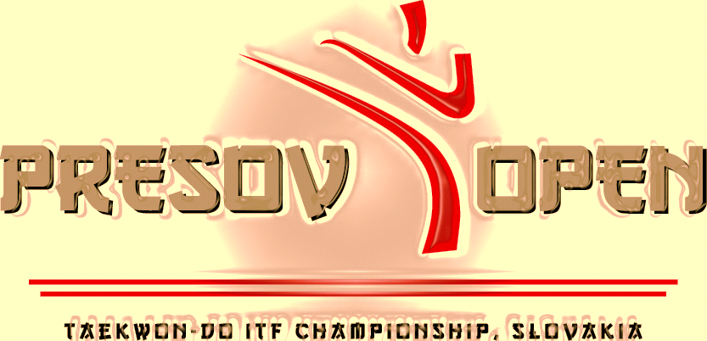

**Dear A.E.T.F. – Members!**  
  
 On behalf of the Sport Club Taekwon Do GE-BAEK Prešov, I have the honour to invite you to the

***14th Presov Open - Taekwon-Do ITF International Tournament***

to be held in Prešov on March 12th to 13th, 2016.

The Championship shall take place in sport hall " **ZS Sibírska „– Slovakia.**

The ***Presov Open*** has been an annual event since the year 2002, when was the first pilot competition. The tournament will be for children from 6 years old, juniors and seniors -coloured and black belts. Event includes: individual pattern, sparring, special techniques, power breaking, team pattern and team sparring.

Slovakia is situated in the middle of Europe. The capital city is Bratislava. Airports with international conections are in Bratislava, Poprad and Kosice. Official currency is Euro. *Prešov* has over 200 thousand inhabitants and it is the third biggest town in Slovakia*.*

We quarantee the high level of the competition and we are looking forward to your participation!   
  
 *With kind regards*

*Tomáš Olejár*

*The president of the Sport Club Taekwon Do GE-BAEK PREŠOV*

